THE BRITISH INTERNATIONAL HISTORY GROUP (Under the Auspices of BISA)

TWENTY THIRD ANNUAL CONFERENCE

UNIVERSITY OF STRATHCLYDE

8-10 September 2011

The Group

The British International History Group is organised under the auspices of the British International Studies Association (BISA). The Association acts as a professional body for teachers, researchers and practitioners interested in the area of International Studies, including International History. The Annual Conference of the British International History Group brings together International Historians from a variety of backgrounds and offers them the opportunity to exchange views.

The Conference

The main work of the conference takes place in panels with four sessions on Friday and Saturday mornings. There will also be two keynote lectures on the first and second evenings, a round table session early Thursday evening and a plenary session on Friday afternoon. The Annual General Meeting will be held during the conference. The keynote lecture and conference dinner on Friday will take place at Glasgow City Chambers.

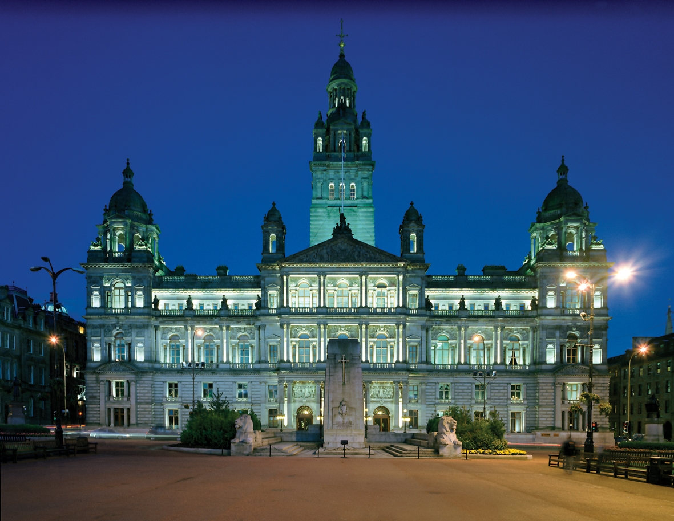
Round Table Session – Thursday 8 September - 17.00-18.15

Professor Simon Ball, University of Glasgow, Professor Campbell Craig, University of Aberystwyth, Professor Peter Jackson, University of Strathclyde, and Dr Joe Maiolo, King’s College London, ‘Practising International History: national and multinational approaches’.

Keynote Lecture – Thursday 8 September – 19.15-20.15

Professor Andrew Williams, University of St Andrews, ‘Waiting for Monsieur Bergson: Nicholas Murray Butler and the French Sage’.

First Panel Session - Friday 9 September - 9.15-10.45

Panel A

Dominic Bray, University of East Anglia, ‘A Liberal Unionist foreign policy. Author: Joe Chamberlain or J.L. Garvin?’
Patrick Bourne, University of Leeds, ‘The voice of the Old Diplomacy?: Sir Frank Lascelles and Anglo-German relations, 1895-1914’.
William Mulligan, University College Dublin, ‘1911: prospects and prophecies of war’.

Panel B

Phoebe Chang, London School of Economics, ‘Understanding the Chinese chameleon: British representations of China up to 1925’.
Antony Best, London School of Economics, ‘The Smuts speech, the Cliveden Set and the power of public opinion: Britain, the United States and Japan in 1934’.
Seung-young Kim, University of Sheffield, ‘Korean Trusteeship Plan as peace-maintenance scheme, 1941-1948

Panel C

Greg Kennedy, King’s College London, ‘The ties that bind: imperial networks and security, Lord Crawford and Balcarres and the Governor Generals to Australia and Canada, 1930-1939’.
Gregor Davey, King’s College London, ‘From local to centrally coordinated Intelligence machinery: British imperial intelligence systems, 1880-1956’.
Ashley Jackson, King’s College London, ‘The system of imperial defence in the Indian Ocean region during the Second World War: networks of command, infrastructure and military resources’.

Panel D

Lorna Lloyd, University of Keele, ‘Canadian Representation on the League of Nations Council, 1927-1930; a case study in the new Diplomacy’.
Declan O’Reilly, University of East Anglia, ‘Constructing heroines: the George Cross, women’s Special Operations Executive agents and post war British consciousness’.
Marco Wyss, ETH Zurich, ‘British armaments policy towards Switzerland in the early Cold War’.
Panel E

Gerald Hughes, University of Aberystwyth, ‘By their long memories the gods are known: Britain and appeasement after Yalta’.
Luca Maggioni, University of Florence, ‘Arnold Toynbee and international relations at the beginning of the Cold War’.
Emma Peplow, University of Glamorgan/London School of Economics, ‘Occupying Berlin, 1945-1946: stumbling into the Cold War city’.

Panel F

Graham Jevon, University of Oxford, ‘Anglo-Jordanian relations, 1945-1958’.
Chikara Hashimoto, University of Aberystwyth, ‘Counter-subversion and British intelligence in the Middle East, 1955-1965’.
Christianne Gates, University of East Anglia, ‘Maintaining British influence in the Middle East: the Anglo-Turkish relationship, 1947-1952’.

Second Panel Session - Friday 9 September - 11.15-12.45

Panel A

Thomas Davies, City University London, ‘The emergence of the international non-governmental organisation in world politics, 312-1855’.
Mathilde von Bulow, University of Nottingham, ‘AFL-CIO and Labor diplomacy during Algeria’s War of Independence, 1954-1962’.

Panel B

John Fisher, University of the West of England, Bristol, ‘Mesopotamia in the official mind before, during and immediately after the First World War’.
David Whittington, University of the West of England, Bristol, ‘Leo Amery and the Balkans, 1915-1916’.
Ayro Makko, University of Stockholm, ‘Great power politics and the League of Nations revisited: Britain, Turkey and the Mosul dispute (again)’.

Panel C

Saho Matsomoto-Best, Nagoya University, ‘Myron Taylor and the American diplomatic mission to the Vatican, 1936-1952’.
Simon Rofe, University of Leicester, ‘American diplomacy: the United States embassy in London, 1933-1940’.
Craig Saucier, Southeastern Louisiana University, ‘Lord Lothian and the genesis of Lend-Lease, 1940’.

Panel D

Andrew Stewart, King’s College London, ‘The Committee on American Opinion on the British Empire and Anglo-American strategic relations, 1942-1945’.
Jennifer Reeve, University of East Anglia, ‘Shall these doors be closed to them: the British Empire and Jewish refugees, 1938-1948’.
Sarah Frank, Trinity College Dublin, ‘The colonial prisoner of war experience in Vichy France, 1940-1942’.

Panel E
Spencer Mawby, University of Nottingham, ‘Mr Smith goes to Vienna: the World Federation of Trade Unions and Britain’s Cold War in the Caribbean, 1952-1954’.
John Kent, London School of Economics, ‘The United States, the United Nations and Katanga secession: Cold War crisis in the Congo’.
Asahiko Hanzawa, Meiji Gakuin University, ‘The United Nations and end of Empire’.

Panel F

Geoffrey Swain, University of Glasgow, ‘Spinning the Red Web: the Latvian origins of the Soviet mission to penetrate MI6’.
Dimitris Bourantonis, Athens University of Business and Economics, ‘How the Soviets called the western powers’ bluff in the United Nations Disarmament Negotiations, 1954-1955’.
Richard Smith, Foreign and Commonwealth Office, ‘Offering the Soviets a choice: British initiatives in the Afghan crisis, 1980-1981’.

Third Panel Plenary Session – Friday 9 September - 14.00-16.00

Professor Martin Thomas, University of Exeter, and Professor Andrew Thompson, University of Exeter, ‘Empire and Globalisation from High Imperialism to Decolonisation’.

Keynote Lecture – Friday 9 September – 18.45-19.45

Professor Evan Mawdsley, University of Glasgow, ‘December 1941: New War and New World’.

Fourth Panel Session - Saturday 10 September - 9.15-10.45

Panel A

David Brown, University of Strathclyde, ‘The contested legacy of Palmerstonian foreign policy’.
Jennifer Davey, University of East Anglia, ‘She has not a particle of tact: women and diplomacy, 1850- 1878’.

Panel B

Michael Auwers, University of Antwerp, ‘Framed in times of democratisation: the Belgian diplomats’ perception of their representation in the press, 1900-1940’.
Vincent O’Connell, University of Limerick, ‘Left to their own devices: Belgium’s attitude towards Eupen-Malmedy in the aftermath of Baltia’s transitory regime’.
Gaynor Johnson, University of Salford, ‘Sir Ronald Lindsay and Britain’s relations with Germany, 1926-1928’.

Panel C

Neil Forbes, Coventry University, ‘The international crisis and the defence of liberal capitalism: the Rio Tinto Company and the coming of the Second World War’.
Karine Varley, University of Strathclyde, ‘Latin sister or age-old enemy? French relations with Fascist Italy, 1940-1942’.

Panel D

Christopher Sutton, University of East Anglia, ‘Britain’s Cold War in Cyprus, 1945-1955’.
Edward Hampshire, The National Archives, ‘From east of Suez to east of Gibraltar: the Mediterranean and the formation of the Mediterranean strategy in 1968’.
Helen Parr, University of Keele, ‘If it is not love it’s the bomb will bring us together: the politics of Anglo-French nuclear cooperation under the Heath Government, 1970-1974’.

Panel E

Alex Sutton, University of Warwick, ‘An open relationship: Britain, Malaya and the Sterling Area, 1945-1955’.
George Peden, University of Stirling, ‘What difference did the Suez crisis make? Whitehall perceptions of the future of the United Kingdom in world affairs’.
Niklas Rossbach, Swedish Armed Forces HQ, ‘An investigation into the return of geopolitics: the Foreign Office and the role of the City of London, early 1970s’.

Panel F

Alessandro Antonello, Australian National University, ‘Towards a post-Treaty history of the Antarctic, 1959-1980’.
Alasdair Blair, De Montfort University, ‘Bridging the gap: Britain, the European Union and the United States after the Cold War’.
Edmund Brown, University of Leicester, ‘States within states: secession and state failure: the case study of Somaliland within Somalia’.

Fifth Panel Session - Saturday 10 September - 11.15-12.45

Panel A

Thomas Otte, University of East Anglia, ‘Late Victorian Diplomacy and Race in East Asia’.
Geoff Hicks, University of East Anglia, ‘Pouring cold water on Disraeli: rethinking Suez, 1875’.
Takeshi Sugawara, University of East Anglia, ‘Arthur Balfour and imperial defence: India, America and the Anglo-Japanese Alliance, 1902-1905’.

Panel B

Jan Lemnitzer, London School of Economics,’ Perfidious Albion or honest neutral? Britain’s role in the American Civil war reconsidered’.
Antony Lentin, Wolfson College, Cambridge, ‘Elective affinities, divided loyalties and Anglo-German victims of World War One: the case of Sir Edgar Speyer’.
Mervyn O’Driscoll, University College Cork, ‘Ireland, war criminals and the Nuremberg Trials’.

Panel C

Michael Jabara Carley, University of Montreal, ‘Pragmatism and ideology in Anglo-Soviet relations during the 1920s’.
Alastair Kocho-Williams, University of the West of England, Bristol, ‘After the Pact: Soviet-German relations August 1939-June 1941 in the light of new Soviet documents’.
Craig Gerrard, University of Leeds, ‘The annexation of the Baltic States, the British government and international law, 1940’.

Panel D

Dean Kotlowski, Salisbury University Maryland, ‘Maintaining the colonial bond: the United States, the Philippines and the onset of the Cold War’.
Tomoki Konoyoshi, Waseda University Tokyo, ‘Britain and Japan’s exclusion from the South East Asia Treaty Organisation (SEATO)’,
Alessio Patalano, King’s College London, ‘The silent fight: Japan’s Cold War at sea and the development of the submarine force, 1955-1976’.

Panel E

Aidan Condron, University of Aberystwyth, ‘United States-Egyptian joint strategy, 1970-1976: planning and implementation’.
Claudia Castiglioni, Woodrow Wilson Center Washington DC, ‘Through thick and thin: Western Europe-Iran relations from the gold rush of the seventies to the Iran-Iraq ceasefire of 1988’.
Grant Dawson, University of Aberystwyth, ‘Who wants a mission? Canadian Forces’ resistance to peacekeeping in Namibia in 1978’.

Timetable

Thursday, 8 September

1430 onwards - Arrival at the University of Strathclyde, report to reception
1700-1815 Round Table Session
1830 Wine Reception
1915 Keynote Lecture
2030 Dinner

Friday, 9 September

0800-0900 Breakfast 1400-1600 Plenary Session
0915-1045 First Panel Session 1600-1630 Tea
1045-1115 Coffee 1630-1730 BIHG AGM
1115-1245 Second Panel Session 1845 Keynote Lecture and Wine Reception
1245-1345 Lunch 2000 Conference Dinner Glasgow City Chambers

Saturday, 10 September

0800-0900 Breakfast 1115-1245 Fifth Panel Session
0915-1045 Fourth Panel Session 1245 Lunch
1045-1115 Coffee

General Information

Accommodation and Sessions

The conference will be held at the University of Strathclyde. Accommodation, based in the University’s John Anderson Campus, is available and will be allocated on a first come, first served basis. Sessions will be held entirely within the John Anderson campus where lunch, refreshments and dinner will also be served. On Friday 9 September the keynote lecture and conference dinner will take place at Glasgow City Chambers. Further details of location including the University and road map will be sent out near to the conference. If a booking receipt is required you should contact Glyn.Stone@uwe.ac.uk

University of Strathclyde

The University of Strathclyde’s John Anderson campus is located in the centre of Glasgow.

Getting to Strathclyde
http://www.strath.ac.uk/visiting/gettingtostrathclyde/

Driving
http://www.strath.ac.uk/visiting/gettingtostrathclyde/driving/

Trains
http://www.strath.ac.uk/visiting/gettingtostrathclyde/bytrainorcoach/

By Air
Getting into Glasgow from the airports
From Glasgow International Airport, it's 15-20 minutes’ drive into the city - and there are regular airport buses. Service 500 (airport's official Glasgow Shuttle)
http://www.glasgowairport.com/portal/To+and+from+the+airport

Prestwick International Airport is around 30 miles from the city centre and has its own train station with trains running to Glasgow Central Station every half hour and taking approximately 45 minutes. http://www.glasgowprestwick.com/

Parking in the city centre
There are plenty of car parks throughout Glasgow city centre ranging in price depending on location and security. The National Car Park in Montrose Street is closest to the John Anderson Campus and the Buchanan Galleries multi-storey car park is just a 10 minute walk away.

Registration

Registration will take place at Reception from 14.30 to 1800 on 8 September. Delegates will receive full documentation on registration.

Book Exhibition

There will be a book exhibition arranged by publishers.

Conference Fees and Charges

Fees and charges will be: Conference Fee which is payable by all delegates; Full Conference Package or individual requirements. See booking form.

Please indicate your requirements on the booking form and return with your cheque to: Professor Glyn Stone, BIHG Secretary, Department of History, Philosophy and Politics, University of the West of England Bristol, St Matthias Campus, Fishponds, Bristol BS16 2JP.

Please make your cheque, including fee, payable to: British International History Group

